Competition Rules BAF

MICROLIGHTS - Ultralights 3 AXIS

TIMED CIRCUIT & PRECISION

LANDING

2025 Edition
Effective 1 May 2025

Approved by
the 3rd General Assembly of the
BAF Airsports Federation
on 25/4/2026

- Introduction by the commission.

The BAF COUNCIL of BAF Airsports Federation within the framework of its responsibilities proposed an ULTRALIGH- MICROLIGHT COMPETITION REGULATION called 'TIMED CIRCUIT &PRECISION LANDING', which includes a series of tests for the participant’s crews.

The reason for creating this Regulation is that we believe this race will attract more spectators as the aircraft will be closely around the airport and their maneuvers will be visible to the public.

This event is an official BAF event.

- Purpose of the competition.

The purpose of the 'TIMED CIRCUIT & PRECISION LANDING' competition is to test the ability of an ULTRALIGHT crew in 2 tasks.

A)Task 1: Achieving a precisely requested timed passage of the ultralights from the requested point (Punctuality Test) in two unequal circular passages

B)Task 2: Achieving precision landings (Spot Landing Test) in a calibrated landing box
For Task 2 to be held, the competition must be held in fields suitable for such events (adequate runway, no obstacles at the beginning and end of the runway, etc.) which meet the basic safety criteria for flights.
The crews in each round will perform two timed circuits (phases), clockwise or counterclockwise, trying to achieve in each circuit the time given to them by the organizers. Any deviation from this time brings penalty points. Penalty points are also given for the incorrect execution of the circuit, e.g. incorrect execution of the circuit, incorrect execution of the legs or execution of 360º turns in the legs of the circuit as well as the dangerous approach-landing e.g. by touching the nose wheel first in a ULTRALIGHT with a tricycle landing system. They will also perform a precision landing at the end of each circuit, which may result in additional penalty points. At the end of the first circuit they will perform a touch and go while at the end of the second circuit they will perform a full stop landing.
  - Race laps
The rounds, with 2 phases each, which can be carried out, depending on the number of entries, is:
    - In BAF competitions - Either 4 rounds will be held, 3 of which will count towards the standings, and then a 3-round Ranking Final (Fly Off) will be held for the 30% of total competitors with best score (less penalty points).
    - The penalty points from each round for each crew are added together. The winner of the competition is the crew with the fewest penalty points.

- DESCRIPTION OF THE COMPETITION
  - Task 1. Timed circuit

This task is divided into 2 phases:
    - Phase 1.
It begins with the take-off of the YPAM and the execution of the 1st cycle. The start of the cycle timing begins when the aircraft passes over Line 0 of the landing box (BOX). On either side of the white line 0 of the landing box, there will be two cones (orange) to make it easier to identify. After take-off, the aircraft must be maintained for at least 30 seconds, from the moment of crossing Line 0, on the runway track, then execute a circle (vertical leg - leeward leg - main leg - final), left-hand or right-hand (the direction will be given during the briefing), and come for touch and go, in order to cross Line 0 0 of the landing box at the requested time. In this phase the landing point and the time of crossing the Line will be scored 0 (and not at the contact point).
    - Phase 2.
It begins with take-off to execute the 2nd cycle. After take-off, the airplane must be maintained for at least 30 seconds, from the time of crossing Line 0, on the runway trace, then execute a cycle (vertical leg – leeward leg – main leg – final), left-hand or right- hand (given during briefing), and come in for a full landing. Stop. The second cycle will have a different duration than the first cycle and not necessarily the same direction (clockwise or
counterclockwise) as the first. The plane is coming in for landing with the intention of crossing the Line 0 of the landing box in the requested (total) time. In this phase the landing point and the time of crossing the Line will be scored 0 (and not at the contact point)
    - Scoring of the task. Each round, consisting of the 2 phases, will have specific completion times, which will be total. Timing begins when the plane passes over Line 0 of the landing box. The first and second circuit tests also occur when the plane passes over Line 0 of the landing box. The times of these crossings will be aggregated. The penalties for leading or lagging are described below. The time measurement will be done when the plane passes Line 0 of the landing box. and not at the moment of contact of the aircraft with the runway.

  - Task 2. Precision landings
Each lap will have two precision landings within a suitable landing box (BOX) formed on the runway, the first with a touch and go procedure and the second a full stop. Each of the landings of each lap will be a normal approach where the use of flaps, engine and rudder combination will be at the discretion of the pilot. A landing is considered to have been made when both main legs contact the runway.

Special cases:

- If the two main wheels land on boxes with different scores, the box with the highest score will be what will count towards the grading of crew.
- If the two main wheels touch exactly the dividing line between 2 buttons values or between Outside and Box then the crew's scoring is done with the more favorable for the crew.
- The nose wheel must not contact the runway before both main wheels have touched down. Otherwise, the landing is considered dangerous and is subject to penalty points (Penalty P5).

- If a bounce occurs during touch and go or landing:
  - if the first touch is on Line 0 or in one of the Boxes A, B, C, D, E, F, G, H and the height of the bounce is less than or equal to the diameter of the if it is ULTRALIGHT then the first touch is taken into account;
  - if the first touch is on Line 0 or in one of the Boxes A, B, C, D, E, F, G, H and the height of the bounce is greater than the diameter of the wheel of the ultralights then the point where the wheels will touch is taken into account AFTER the bounce;
  - if the first touch is in one of the Boxes X, Y then the point where the wheels touched BEFORE the bounce, regardless of the height;
  - if the first touch is outside the Box then the landing is considered to have been OUT, regardless of where the wheels will land after the rebound.
  - If the wind is strong with a velocity greater than 5 Knots, the runway changes landing and the race continues normally.
- If the wind becomes gusty during a crew's effort and the if the wind speed exceeds 5 knots, the crew may request a repeat of this lap. The decision on whether or not to restart is made by the Race Director after informing the crew.
Appendix 1 shows the shape and dimensions of the landing box and the location of Line 0.

  - Penalties

    - Timing of crossings (P1a, P1b)
For every second of advance or delay, 3 penalty points are charged.
Each time you pass Line 0, 1 second is added or subtracted from the time of the crew of the race in his favor, depending on whether there is a lead or a delay respectively, in order to cover cases of delay in the start of the timing by the judges, etc. In total, a total of 2 seconds are added or subtracted in each round with this procedure.
    - Precision landing rating (P2a, P2b)

Line 0 - 0 penalty points
Box A - 10 penalty points
Box B -12 penalty points
Box C - 14 penalty points
Box D - 16 penalty points
Box E - 18 penalty points
Box F - 20 penalty points
Box G - 25 penalty points
Box H - 30 penalty points
Box X - 20 penalty points
Box Y - 30 penalty points
Outside the box 40 penalty points

    - Fly Off Scoring

      - All crews participating in the Fly Off start with 0 penalty points, regardless of the penalties they had accumulated in the race.
    - The scoring of the Fly Off is done in the same way as the scoring of the
      - In case there are crews who have not flown any laps In the Fly Off, their ranking will be as follows:
        - Crews that have flown in all rounds of the fight.
        - Then, the crews are ranked based on the sum of the penalties
P1a and P1b that they collected in the rounds of the match, excluding round they have rejected, if there is one.
        - Finally, if there is still a tie in some crews, the crews
These items jointly occupy the ranking position that corresponds to them.

    - Other penalties

• Failure to maintain the runway track for at least 30 seconds after takeoff 40 penalty points (P3a, P3b);
• Wrong time of performing a circle 40 penalty points (P3a, P3b);
• Incorrect execution of the cycle, skipping a leg or simply crossing over Line 0 without making a touch and go or landing 60 penalty points (P4a, P4b);
• Performing 360° turns on a leg of the circle or dangerous approach-landing 100 penalty points (P5a, P5b);
• Abandonment or failure to complete a lap 600 penalty points (P6a+P6b);
• Abandonment or non-implementation phase 300 penalty points (P6a, P6b);
• Technical Penalty 50 points from the Race Director to a crew member or Team Leader.
In case of abandonment during a lap, the crew is charged a total of 600 penalty points plus the worst crew score flown in that round, while any other penalties accumulated during the round are not taken into account.
In the event of abandonment during the execution of a phase, the crew is charged a total of 300 penalty points for that phase, while any other penalties accumulated during the phase are not taken into account.
A crew that has not managed to complete at least one phase during the race is not scored and is not included in the race results.
In case of abandonment during the execution of a lap, the crew is charged total of 600 penalty points plus the worst crew rating flown in this round while any other penalties accumulated during the round do not are taken into account.

  - Score calculation examples

The time given for one round is 03:30 for the first phase and 08:00 for the total time. The circuit of the first phase is anti-clockwise and the second phase is clockwise. Crew with the ULTRALIGHT SX-ABC performs the first phase in a time of 03:41 and the second in a total time of 07:39. Performs the 1st touch and go outside the box and the 2nd landing in BOX F, while the 1st He/She incorrectly performs the circuit clockwise instead of counterclockwise. His/Her score will be:
1st circuit delay penalty (P1a) 30 (11 sec delay -1 sec X 3 points/sec)
2nd round lead penalty (P1b) 60 (21 sec prep. -1 sec X 3 points/sec)
1st touchdown penalty (P2a) 40 (out of box)
2nd touchdown penalty (P2b) 20 (BOX F)
Penalty for incorrect execution time of 1st round (P3a) 40
Penalty for incorrect execution time of 2nd round (P3b) 0
Penalty for incorrect execution of a circuit (P4a) 0
Penalty for incorrect execution of a circuit (P4b) 0
Penalty for performing 360° turns (P5a) 0
Penalty for performing 360° turns (P5b) 0
Abandonment penalty (P6) 0
FINAL ROUND SCORING 190
Annex 3 shows the completed Worksheet based on the above example.
- ORGANIZATIONAL ISSUES
  - Organizer of the Games

The organizer of the BAF Championships is BAF AirSports Federation.
The competitions are being held by the Ultralights or microlights in accordance with the provisions of the International Organizations Regulation.

  - Organic positions

The organic positions of the race are the Race Director and the 3-member BAF Jury.
The Race Director is appointed exclusively by the BAF Council. The Race Director is in charge of the design of the race. He is also the Judges Director.
The BAF Council may also appoint an Alternate Race Director in the event if the Race Director is unable to attend and direct the race. Also, the organizer, if he wishes, may request the Committee to send a Technical Advisor for technical support of the race.
The expenses of the Race Director and the Technical Advisor, if requested, (travel, accommodation, meals) are covered in full by the Race Organizer. The intention of BAF council is to select Race Directors and Technical Advisors close to the race locations in order to minimize the financial burden on the Organizer.
The BAF Judicial Committee is composed of its President and two members. The President and the members of the BAF Committee are proposed by the BAF Cuncil.
The mission of the BAFJudicial Committee is to ascertain and certify in what manner provided that the competition is conducted in accordance with the applicable regulations. The Committee has the authority to ability to make whatever decision is necessary depending on the circumstances and to arrange attitudes or differences between the athletes/teams. Its decisions are binding on the parties involved.
Both the Race Director and the members of the BAF Jury and the Committeet cannot participate as competitors in the race in which they hold an organic position.
During the race, the Race Director, the judges and the timekeepers will be within a demarcated square measuring 15m X 15m, into which no crew member or Team Leader is allowed to enter unless called by the Race Director. In the event of a crew member or Team Leader entering and not complying with the Race Director's instructions, the latter may impose a Technical Penalty of 50 points on the of this crew or in a lap of each crew of the team, respectively.

  - Aircraft

Only ULTRALIGHT members in the following categories can participate in this competition:

- RAL2 (3-axle, land, two-seater)

In order for a competition to be held in a category, 6 crew must have registered to participate and 3 countries BAF MEMBERS.

The ULTRALIGHT participating in the race must be equipped with the necessary equipment and documents provided for by the respective ULTRALIGHT Operation Regulation REGISTRATION.

  - Judges
The minimum number of judges for the competition is three:
  - Runway Judge: He notes the times when the ULTRALIGHT passes Line 0 of the landing box, with an accuracy of one second, during the 2 circuits in order to calculate the delay or advance penalty. He is also responsible for monitoring the correct execution of the circuit (correct time, correct execution, 360º turns, abandonment) so that the appropriate penalties can be imposed. The judge should be equipped with 2 suitable sports timers one for the 1st phase of the round and one for the total time. Due to the importance of timing in the race, under no circumstances should time be measured with wristwatches, mobile phones or tablets.
  - Assistant Track Judge: Carries 2 stopwatches and acts in parallel and auxiliary of the Runway Judge to deal with the case of someone malfunctioning timer or human error.
  - Landing Judge: Marks the ULTRALIGHT landing point on the 2 approaches. groundings. He also acts as an assistant to the Range Judge during the remaining phases of the match.

The Track Judge is designated as the head of the 3 judges and is responsible for the completion of the special form for each round and each crew to facilitate the Race Director is the head of all the judges who approves the judges for each match. It is advisable to have alternate judges so that they can assist if necessary.

  - Weather
The race can only be conducted in VMC conditions, as defined by ICAO and subject to national standards for flights under VFR conditions.
If the prevailing weather conditions at the time of the race make the preparations unsafe, precision landings then Task 2 of the Precision Landing may not be scored, with decision of the Race Director and the race will continue with scoring only Task 1. The decision not to score Task 2 will be made for each round separately and will be valid for all participating crews.
If weather conditions deteriorate during the race, making it unsafe to crews' flights, it is at the discretion of the Race Director to interrupt it. In the event of a race being interrupted due to worsening weather, if one or more laps have been completed, then the provisional race results will be based on these laps. If no laps have been completed, the race will be being considered unrealized.

  - Crews
The aircraft crew consists of the Captain and, in two-seater ULTRALIGHTs, the Co-pilot, who must belong to the same BAF MEMBER NAC.
For any category to be held in a race there must be minimum 6 entries from at least 3 countries in this category.

It is possible for up to 3 different crews to compete with the same ULTRALIGH as long as this is possible in time and with the approval of the Director Fight.
In the event of a technical failure, the Race Director may authorize the use of another ultralight, if available.
In the case of two-seat ULTRALIGHTs, the Co-pilot is not required to hold a ULTRALIGHT pilot license or higher. Crews should take the following into account when registering for participation:

- Crews who declared their participation in a two-seater category on time but the co-pilot A is unable to fly, for any reason, cannot take part in the race.
- Changes in the composition of the crews, in relation to their initial declaration, are NOT ALLOWED.
- When registering crews in a two-seater category, it is possible to declare the names of 2 co-pilots are entered on the special form and finally he flies to one of the two fights.
  - Simultaneously with the sending of entries and for them to be considered valid, The Entry Fee for each crew, as determined in the 1st Newsletter. Beyond this deadline, failure to send the proof of deposit constitutes invalid entries. The Participation Fee only covers the costs of the organization. In no case does it cover travel, accommodation and food expenses. crews' reputation.
- The Participation Fee can only be refunded to those crews cancel their participation in writing, no later than 20 days before the time of the official start.

  - Videography-Audio Recording

There must be video surveillance with a high-resolution camera, with mobile phones and tablets blocked, of all precision landings of the race and from a position that clearly shows the point of first and final contact of the main leg with the ground, so that it can be used, if necessary, in the event of an objection.
If possible, the Boxes can be numbered with large, clearly visible numbers (-2, -1, 0, 1, 2 etc.) or letters (Y, X, 0, A, B, C etc.) so that the point of contact is easier to identify and also the camera records the date and time. Also, if it is technically feasible, all phases of the match can be videotaped for use in the event of protests.
Finally, if possible, aircraft and ground communications should be recorded. for safety reasons.

  - Additional Penalties
Crew which during the race:
violates the competition regulations;
violates safety rules;
exhibits inappropriate behavior;
endangers athletes, spectators or property with his flight;
cheats the match,
may receive at least a verbal warning and in case of a repeat or serious violation, may be disqualified and asked to immediately leave the competition.

The decision to disqualify is made by the Competition Director after a recommendation from the judges or a documented complaint from athletes.
Crew showing signs of intoxication are not allowed to start the engine of his ultralights and is excluded from the race.

  - Competition Days – Briefing

For the smooth running of the Championship the day before the races is mandatory for crew briefing .
Crew briefing presents details about the race, the race files are delivered to the crews, a weather briefing is given as well as information on the procedures in force during the race.
Also, a draw is made to determine the order in which the crews will compete in the race and the times for the phases are announced by the Race Director.
A crew of which at least one member does not take part in the briefing is excluded is removed from the race without the right to a refund of the Entry Fee.
The time task is given in the day of the race before the start at weather briefing.
Smoking is prohibited in all briefings held indoors.

  - Objections

Objections are submitted in writing and only by the Leader of each team. In the objection The article of this Regulation that has been violated must be clearly stated.

Along with the protest, a sum of money is paid, the exact amount of which is determined by the organizers of each race and is stated in the 1st Information Bulletin issued before the race. The protest is judged by the BAF Arbitration Committee. If there is no unanimous the decision is taken by majority vote. In case the objection is justified, the amount This is returned.

In case of an objection regarding the precision landing, the video of the race is only acceptable evidence while photographs as evidence are excluded.

4.11. Results
After the end of the race, race sheets are issued for each crew, which show the following: the analytical score and all the participants MANDATORY receive knowledge of them teams that participated in the race so that they can, if they wish, submit evidence After a reasonable period of time has elapsed and any objections have been heard,
After the appeals, results are issued and the awards are made. The results are sent to BAF on the same day, signed by the Race Director. and the BAF Judicial Committee.

In the event of a tie, the ranking is initially based on the lowest sum of the lead/lag penalties of all rounds (sum of penalties P1a+P1b). In the event of a new tie, these crews will occupy jointly the same position.
The results must be issued in 2 formats:
- Analytical. In addition to the above information, the score for each task and how it is derived are listed in detail. In Annex 4 there is a sample Analytical Scoring Sheet;
- Summary. Only the names of the crew, the club, the ULTRALIGHT registry and the overall score. In Annex 5 there is a Sample Summary Score Sheet.
If possible, there may be a board in the crew area for posting announcements, provisional results of each round, etc.

4.12. Awards
Medals are awarded to the first 3 crews in race while forms Commemorative diplomas are awarded to all crews participating in the race.

There is also the possibility of awarding special prizes, in each race separately, if special reasons exist and upon a relevant proposal. Examples of special awards are:
    - awarding the NAC with the most participations in a match;
    - award to the crew that will receive zero penalty points in the test timing;
    - award to the crew that will receive zero penalty points in the test of landings.
The provision of special prizes can also be done by sponsors.

4.13. Language
The official language of the race is English used as operational terms, (ICAO terminology).

4.14. Time
Th
e official time of the race will be local time.
4.15. Newsletters
Information Bulletin is sent electronically to all BAF MEMBERS 60 days before the date of the race. The 2st Bulletin is sent electronically 25-30 days before the date of the event.
The Information Bulletins are prepared with the care of the BAF Ultralight Committee and are also posted on its website.

4.16. Match Sheet
After the end of the race the Race Sheet is sent to BAF COUNCIL, which is signed by the Race Director and the members of the Hellenic Arbitration Committee.

4.17. Scoring Software

The race scoring software will be provided from BAF Committee.

4.18. Crew hygiene and rest areas
In BAF Championship, the hoster organization must have sanitary facilities and shaded areas rest periods for the crews. Failure to comply with this condition will result in the cancellation of the match by decision of the Match Director.

4.19. Aircraft in the air during the race

In each round there is normally one plane in the air. However, if the configuration of the airport allows it (sufficient taxiways, possibility of immediate runway clearance without the need for backtracking, etc.) it is possible for up to 2 aircraft, of equivalent performance, to be in the air in each lap with sufficient separation between them. It is proposed that when the 1st aircraft is downwind in the 2nd phase of its lap, the 2nd aircraft takes off and begins the 1st phase of its lap. In this case, there should be more judges for the scoring of the two crews.

4.20. Installing a camera in the cockpit In the races (Panhellenic, Regional, Cup) it is planned to install a camera in the cockpit that records the crew and the instrument panel. The camera footage is checked by the Race Director and in case it is found that a crew cheated the race (use of GPS or other technical aids, etc.) a penalty of exclusion from the race is imposed on it.

ANEXES
ANNEX 1

PRECISION LANDING BOX

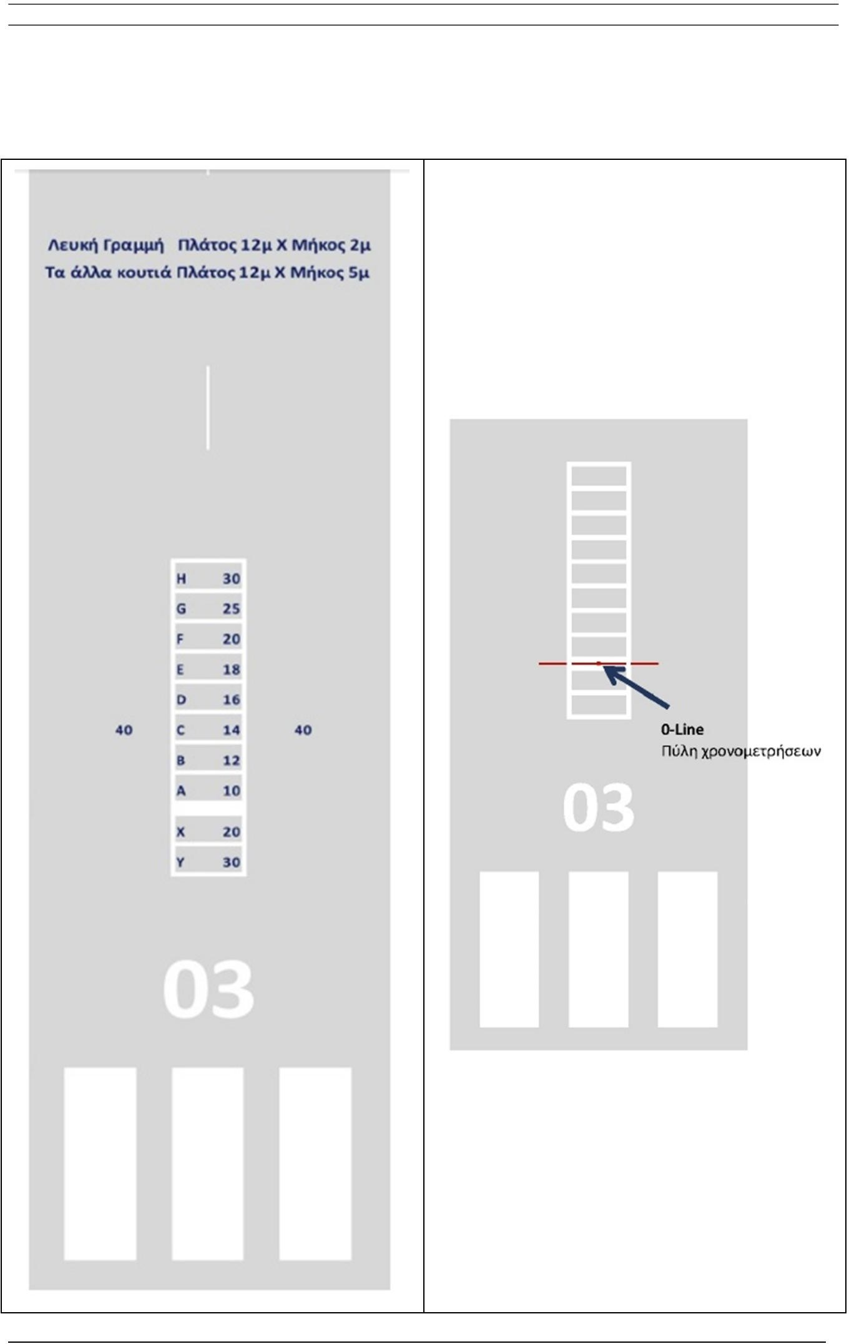

ANNEX 2

WORKSHEET EMPLATE

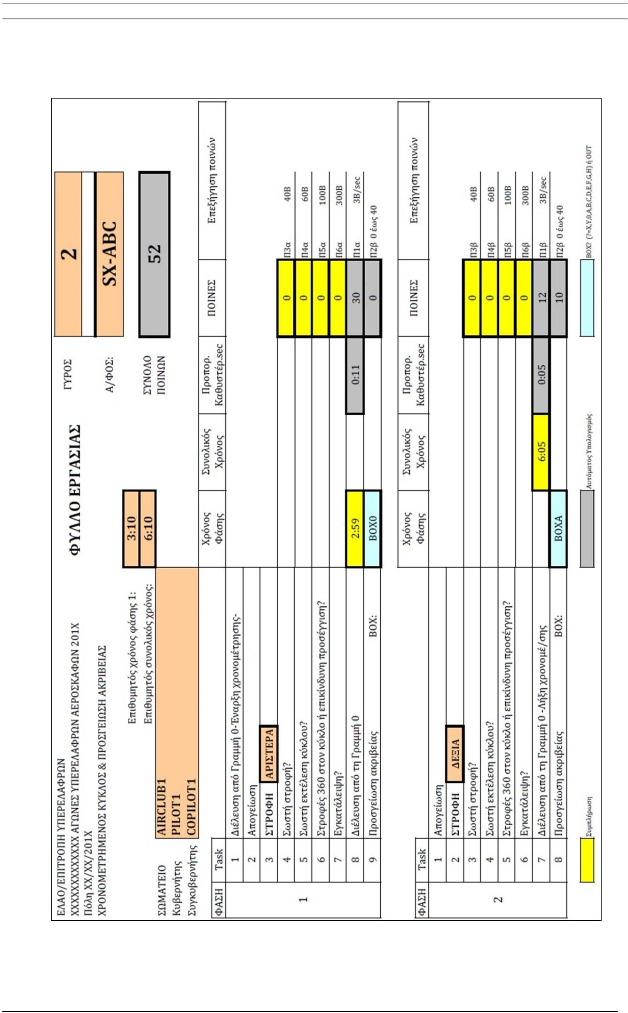

ANNEX 3

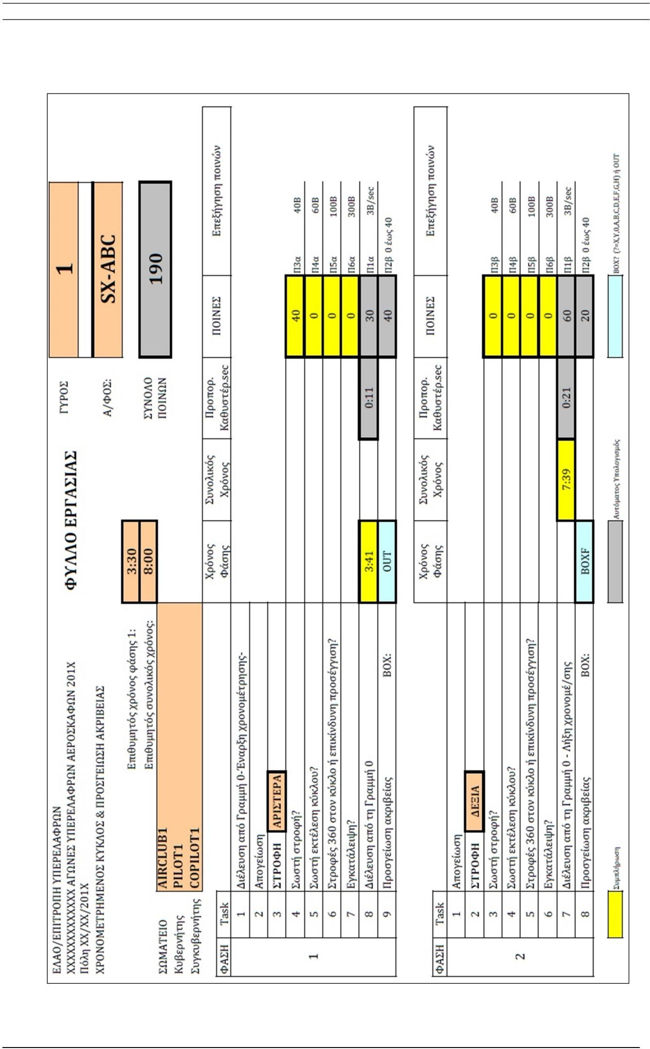
WORKSHEET SAMPLE BASED ON THE EXAMPLE ON PAGE 5

ANNEX 4

SAMPLE ANALYTICAL SCORE SHEET
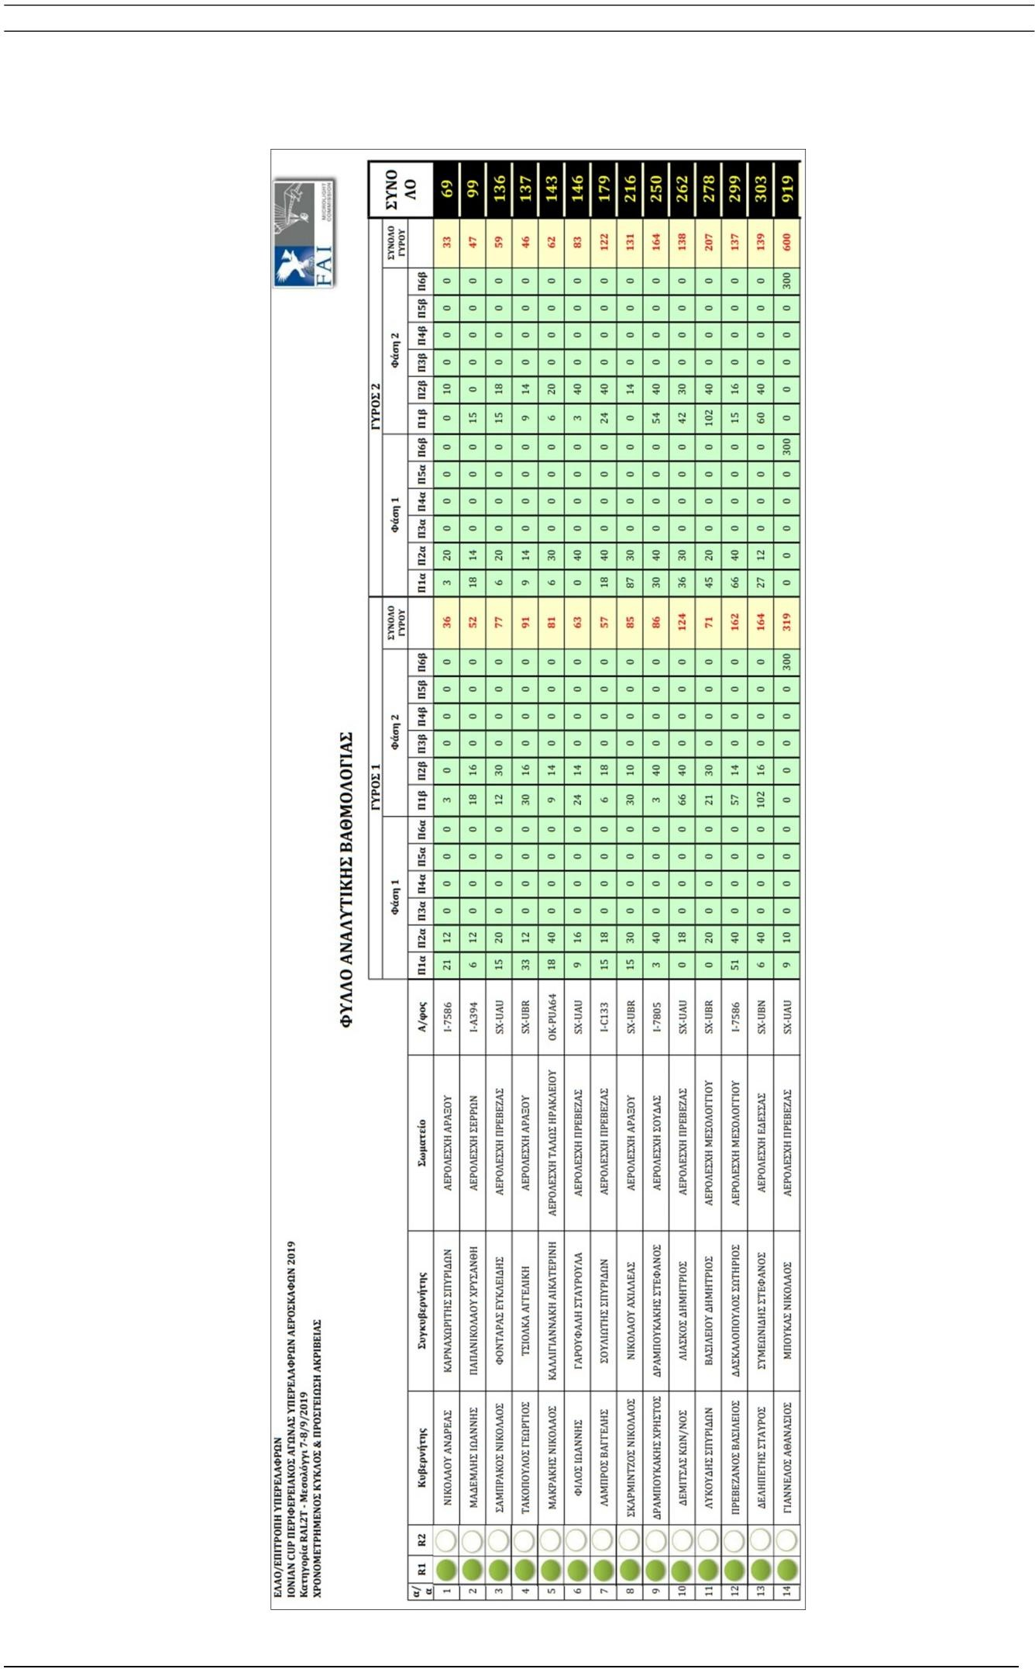

ANNEX 5

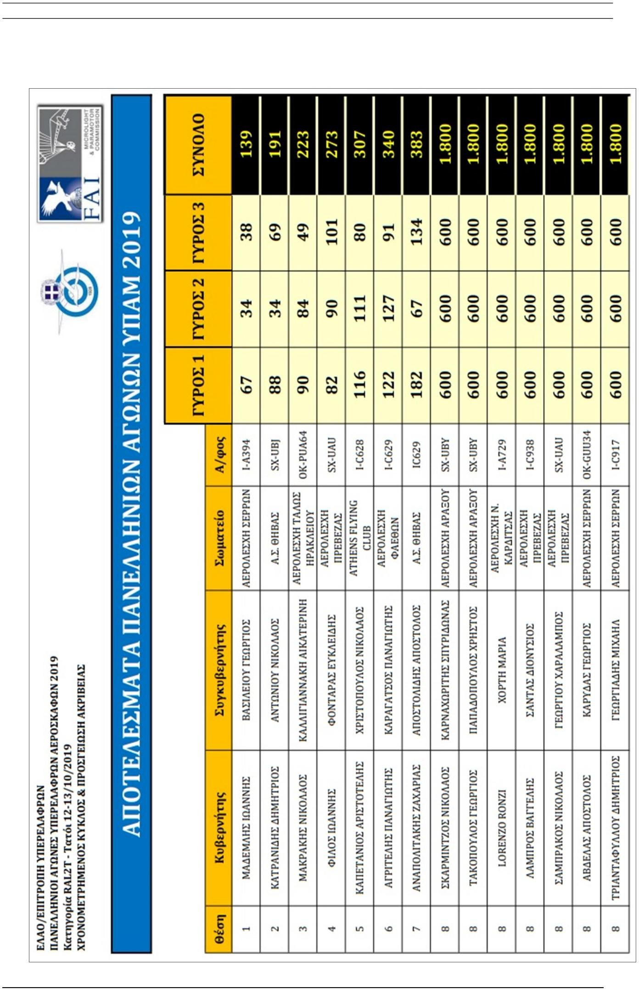
SUMMARY SCORE SHEET TEMPLATE

ANNEX 6

COMPLAINT FORM TEMPLATE
